Tyler Butler Lab 3 Assignment

**1. restaurant Bill (40)**

Write a program that computes the tax and tip on a restaurant bill. The program should ask the

user to enter the charge for the meal. The tax should be 6.75 percent of the meal charge. The tip

should be 20 percent of the total after adding the tax. Display the meal charge, tax amount, tip

amount, and total bill on the screen.

**Answer:**

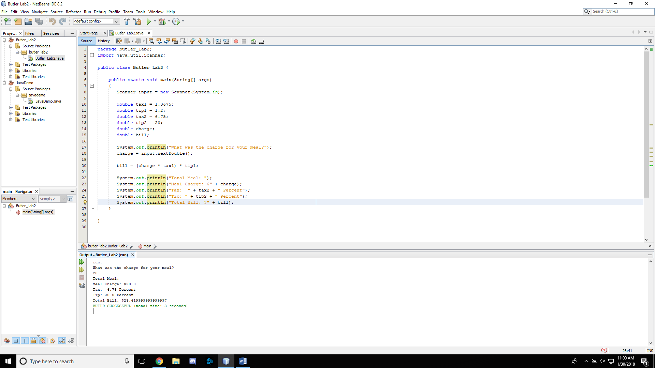

**2. Word game (60 point)**

Write a program that plays a word game with the user. The program should ask the user to

enter the following:

His or her name

His or her age

The name of a city

The name of a college

A profession

A type of animal

A pet’s name

After the user has entered these items, the program should display the following story, inserting

the user’s input into the appropriate locations:

There once was a person named NAME who lived in CITY. At the age of AGE, NAME

went to college at COLLEGE. NAME graduated and went to work as a PROFESSION.

Then, NAME adopted a(n) ANIMAL named PETNAME. They both lived happily ever

after!

